­­

**The Republic of Iraq**

**Ministry of Higher Education & Scientific Research**

**University of Wasit**

**College of Education for Pure Science**

**Computer Sciences Department**

Design Network

for Wasit University

Student Preparation:

**Mahmoud Shamran**

Supervised by:

**0000-0000**

Supervisor Certificate

I certify that the preparation of this project entitled " Design Network for Wasit University " for Graduation project in Computer Science Department / College Education for Pure Sciences Wasit University, prepared by “Mahmoud Shamran”, partially fulfilling the requirements of a Bachelor's degree of Computer Science.

The name:

Date:

Signature:

**Examination Committee Certification**

We certify that we have read the project titled “Design Network for Wasit University” and as examination committee, examined the student “Mahmoud Shamran” in its content and that in our opinion; it is adequate as fulfill the requirement for the degree of B.Sc. in Computer Science.

Signature:

Name:

Date:

Signature:

Name:

Date:

بسم الله الرحمن الرحيم

))هُوَ الَّذِي بَعَثَ فِي الْأُمِّيِّينَ رَسُولًا مِّنْهُمْ يَتْلُو عَلَيْهِمْ آيَاتِهِ وَيُزَكِّيهِمْ وَيُعَلِّمُهُمُ الْكِتَابَ وَالْحِكْمَةَ وَإِن كَانُوا مِن قَبْلُ لَفِي ضَلَالٍ مُّبِينٍ ((

صدق الله العظيم

### **[سورة الجمعة - الآية 2](http://quran.ksu.edu.sa/tafseer/katheer/sura62-aya2.html)**

# **الإهــــــــــــــــــــداء**

انتهت الحكاية رفعت قبعتي مودعآ للسنين التي مضت

أهدي تخرجي الى بحر الحب والحنان والنبض الساكن في عروقي أمي الحنونه وأبي العزيز الذي كان لي سندآ في الحياة الذي يرقد تحت التراب الى نجوم سمائي المتلألئه وسندي في الحياه الى اخوتي التي لم تلدهم امي ولكن ولدتهم لي الايام كانو سندآ لي بفضلكم اقف في هذا الموقف الجميلشكرآ لكل اصدقائي شكرآ الى اساتذتي شكرآ لكم.

# شكر وتقدير

ونحن على أبو اب التخرج، نتقدم بتحية شكر صداها الاحترام والتقدير لكل من ساهم في إظهار هذا البحث بهذه الصورة ونخص بالذكر الدكتور ("") الذي وقف معنا وقفة جادة في سبيل إنجاح هذا البحث. والا يفوتني في هذا المقام إلا أن أقدم جزيل الشكر إلى كل الأساتذة الإجلاء في قسم الحاسوب شاكرا لهم فضلهم علينا. كما أود أن أشكر زملائي الأعزاء الذين كانوا دائما ومازالوا مثالا للإخلاص والوفاء والتعاون في العمل.

# **Abstract**

Campus Network (CN) is a set of Virtual Local Area network (VLAN), which covers the entire university. It provides difference service such as connect user to internet, data sharing among user, accessing different web service for different functionalities. As Campus Network (CN) provides students, teachers, and different university member for different application, to sustain different activities in the university, so it needs to design in advance. To sophisticate the campus network service, this paper proposed Smart Campus Network Design (SCND) by integrating internet of thing device with classically network device in campus network and each smart device for different application must be registered to IOE server and controlled by legitimate user. To design the proposed campus network design, I used cisco packet tracer simulator software.

List Of Contents

**سورة الجمعة - الآية 2** iii

**الإهــــــــــــــــــــداء** iv

شكر وتقدير v

**Abstract** vi

Chapter One 1

Introduction 1

Chapter Two 9

Devices 9

**2-4-2. Routers:** 13

**2-4-3. Wireless:** 14

**2-4-4. Network Security:** 14

**2-4-6. Network management:** 14

**2-4-6. WAN optimization** 15

**2-5. Cisco wireless** 15

Chapter Three 18

Design 18

3-2. Design: 21

**1 - Service Provider:** 21

**2 -Network Distributions :** 21

**3- Faculty of Education:** 21

**4- College of Science :** 23

**5- College of Engineering :** 23

**6- Faculty of Administration and Economics:** 23

**7- Faculty of medicine :** 24

**8- College Of Law :** 24

**9- Data Storage Server :** 24

Chapter Four 27

Chapter Five 33

References 34

List of Figures

Figure 3. 1 - Department Math 22

Figure 3. 2 - Department Biology 22

Figure 3. 3 - College of Science 23

Figure 3. 4 - College of Engineering 23

Figure 3. 5 - - Faculty of Administration and Economics 23

Figure 3. 6 - Faculty of medicine 24

Figure 3. 7 - Ping Connection 25

# Chapter One

# Introduction

**1.1. Networks:**

A computer network can be defined as a group of computers and other devices that connect to each other through communication media, which allows the sharing of a number of resources between users, such as printers and scanners, and it also allows the sharing of files and various programs, and other features of computer networks are ease Access to information on the network by other users.

**1.1.2. Types of computer networks according to their size:**

Computer networks can be classified according to their size as follows:

1. **Local Area Network: (LAN)**

which is a group of computers that communicate with each other within a small geographical area. The computers in this network belong to the same organization. The local network is the simplest form of computer networks, and the speed of data transmission in it reaches up to 1 Mbps, and can go up to 10 Gbps.

1. **Regional Network: (MAN)**

which is the network that connects several local networks within medium geographic areas that may reach several miles, and the regional network is usually connected through high-speed communication media; such as optical fiber cables.

**3. Wide Area Network: (WAN)**

which are those networks that cover very large geographical areas, and the global Internet is one of the most famous examples of wide networks, and the speed of wide networks varies according to the different means of communication used. Types of computer networks according to the method of connection Computer networks are divided according to the way they are connected to many different types, and among these types are the following:

**4. Star Network: (Star Topology)**

which is the network in which computers are distributed around a central device, and data is communicated from one device to another through the network through the central device. Entire crash.

**5. Linear network:**

(Bus Topology), which is the network in which all devices are connected via a single line of wires, and the linear network is one of the cheapest and easiest types of networks in terms of adding any device over the network, and this network is completely disrupted if any cut occurs in the central cable.

**6. Ring Topology:**

In which computers are connected in a closed loop, when a message is sent in this network, it passes through all the devices between the sender and the receiver.

* 1. **Introduction:**

Local area network (LAN) is a network that is controlled by single authority (e.g. CN). Campus network (CN) is set of virtual local area networks (VLAN), which are virtual divided for increasing the performance of network and increases campus network management with security. While the term “Internet of Things” (IoT) was first announced, the primary question might be what is considered as “Things”. Till current years, groups of scholars and organizations tried to make clear the definition of IoT. Haller et al. proposed a definition of IoT with “A world where physical objects are seamlessly integrated into the information network, and where the physical objects can become active participants in business process.” To spread the coverage of IoT definition, Samra et al. defines the “Things” from physical objects to virtual objects which represents as the identities with Internet connectivity. Although IEEE IoT Initiative is proceeding to draft a white paper for the formal definition of IoT there are still no common agreements for the definition of IoT.

* 1. **University of Wasit:**

The university hosted three faculties that were linked administratively and scientifically to the University of Al-Qadisiyah. These faculties were the first building blocks of the future University (Wasit University), which are: the College of Education, which received its students in the 1996-1997 school year, the College of Administration and Economics, which was established in the academic year 2000-2001, and the College of Science Which was opened in the academic year 2001-2002.

After the university strengthened the progress of the three faculties, provided them with their requirements and increased their capabilities and staff, in the 2005-2006 academic year, a campaign began to create new faculties, departments and centers; The faculties of Arts, Medicine, Engineering, and Law were opened, as well as the Department of Physical Education in the College of Education, the Central Library of the University, the Engineering Consulting Office at the College of Engineering, the Computer and Informatics Center, the Continuing Education Center, and the Student Housing Department.

The year 2008 witnessed the opening of the College of Agriculture and the College of Basic Education, as well as new departments: the Department of Oriental Studies in the College of Arts, and the Department of Chemistry in the College of Science. Due to the increasing number of students and the high demand for the Department of Physical Education, it was developed and transformed in 2010 into an independent college, and in 2011. The College of Veterinary Medicine was opened in the district of Al-Hayy, and the year 2012 witnessed a qualitative leap in the university’s progress, as four colleges were opened (the College of Dentistry, the College of Computer and Mathematics, the College of Fine Arts, and the College of Mass Communication). Wasit University did not stop at creating colleges or scientific departments, but rather the establishment of Postgraduate studies (Master’s, PhD) in faculties: (Education, science, management, economics, engineering, medicine, physical education, sports sciences, literature, and fine arts), as well as a post-doctoral study in the Department of History, and the opening of several advisory centers at the Faculty of Agriculture, Administration and Economics In 2018, the College of Education was separated into the College of Education for Human Sciences, which includes the humanities departments, and the College of Education for Pure Sciences, which includes three departments (computer sciences, life sciences e, mathematics),

In 2020, the College of Computer Science, Information Technology and Mathematics was opened.

* 1. **Student information:**

The total number of students of Wasit University is 24,000

* 1. **Router:**

Devise Source is a device that receives data from the source device. Searches for the address of the receiving device, Devise Destination, and sends this data to it, which is of two types:

1. Router
2. wireless
   1. **Router properties:**
3. It works in three layers (Network, link Data, Physical)
4. contains a table Hush It stores the addresses of the devices
5. working to change the address Physical For both sender and receiver
   1. **Switch:**

It is a device that receives data from the source device It directs it and sends it to the receiving device and send this Switch properties

1. It works in two layers (link Data, Physical) or in the three layers
2. There is no table Hash
3. Does not work until change of address physical for both sender and receiver.
   1. **Project requirements:**

The requirements that the project needs on the virtual environment

1. Windows
2. Cisco Packet Tracer
3. CPU: Intel Pentium III 1.0 GHz or better
4. RAM: 512 MB or more
5. Storage: 300 MB of free disk space
6. Screen resolution: 1024 x 768
7. Sound card and speakers
8. Internet connection: 56K Dial-up or faster (if using the Multiuser feature) The requirements that the project needs on the practical environment :-
9. Routers
10. Switches
11. Cables (street, Crosse Over).
12. Personal Computers
13. Printer
14. Access point
    1. **Project Analysis**

Pre-study at this stage, a comprehensive and superficial survey of the existing system is carried out. And to identify the problems of the existing system superficially, not to delve into its problems, but to give us a clear view of the problems of the system and the extent of its shortcomings. These include: The stage has the following steps:

* Defining the problem
* setting goals
* Work plan counter
  1. **Defining the problem:**

As previously it was identified how the procedures within this system are conducted, and how to communicate between the presidency of the university with other faculties on the basis of using the previous system had many negatives, including:

* The time spent in the communication process between the presidency of the university and the faculties

Unreliability in traditional data transmission

* Excessive costs as a result of the traditional communication process
  1. **Work plan counter:**

After we were assigned to work on this project, we worked on dividing the work between a team The project ‘Based on the proposals and objectives of the system, we prepare the plan The work includes a number of required materials, which can be identified as follows:

* + human resources: It includes team members
  + technical resources: From hardware, hardware, software and networks
  + financial resources: This includes providing the internet, printing, and others Detailed study

Since the preliminary study is a superficial coverage to identify system problems The communication network, as explained previously, the detailed study takes on a more general and comprehensive meaning Where you are interested in studying the problems in some depth, if you have to go through a number of procedures to accomplish this study, we prepared and implemented the

following set of steps

* To plan to conduct this study (detailed study)
* data collection
* data registration
* data encoding
  1. **Planning for a detailed study:**

Where the system that will be subject to study and analysis has been determined, which is linking the presidency of the university with colleges through a wireless network, the tasks were distributed among the work team, and the necessary data to be collected and to prepare a timetable for the completion of this study, and this is done during the study. Introductory and we have identified the methods and methods that will be used to accomplish this system in the operations data collection.

* 1. **Type of wires**

|  |  |  |
| --- | --- | --- |
| # | Cable Type | Price /m |
| 1 | UTP | 0.19 $ |
| 2 | STP | 0.28 $ |
| 3 | Fiber |  |

* 1. **Wireless & Wired**

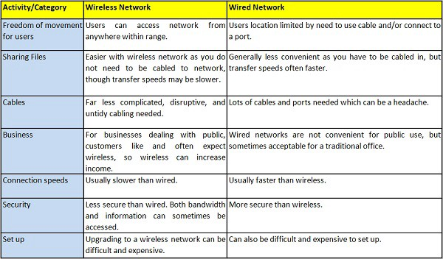

# Chapter Two

# Devices

**2-1. Routers:**

Brand router. Routers for all types and scenarios Choose the router that best suits your needs. The router is connected to two or more data lines from different IP networks. When a packet enters a line, the router reads the network address information in the packet header to determine the final destination. Next, use the information in the routing table or routing strategy to route the packet to the next network on its journey.

Routers can provide connections within an enterprise, between an enterprise and the Internet, or between Internet Service Provider (ISP) networks. Larger routers connect multiple Internet service providers or can be used in large corporate networks. Smaller routers typically provide connections for typical home and office networks. Different types of routers can be used to meet different needs.

Brand quality routers to meet your needs.

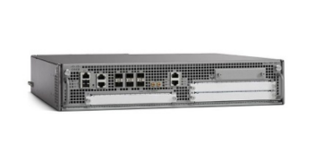

Cisco routers provide ISR (Integrated Service Routers), ASR (Assembly Service Routers) and other series for networks of all types and sizes, including branches, service providers, SMEs, etc.

* [cisco router ISR 4000](https://ar.router-switch.com/Price-cisco-routers-cisco-router-4400-series_c119)
* [cisco router ASR 1000](https://ar.router-switch.com/Price-cisco-routers-cisco-router-asr-1000_c13)
* [cisco router ISR 900](https://ar.router-switch.com/category-cisco-900-isr-price.html)
* [cisco router ASR 9000](https://ar.router-switch.com/Price-cisco-routers-cisco-router-asr-9000_c43)

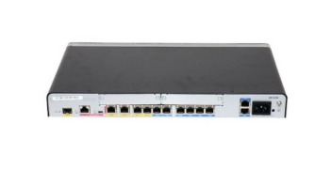

Huawei provides flexible network services and connections using proven and best-in-class IP routers.

* [موجهات هواوي AR1200 للمؤسسات](https://ar.router-switch.com/Price-ar1200-series-enterprise-routers_c244)
* [موجهات هواوي AR2200 للمؤسسات](https://ar.router-switch.com/Price-ar2200-series-enterprise-routers_c245)
* [هواوي AR530 Agile Gateways](https://ar.router-switch.com/Price-ar530-series-agile-gateways_c280)
* [موجهات Huawei NetEngine](https://ar.router-switch.com/Price-netengine-series-routers_c255)
* [جميع أجهزة راوتر هواوي](https://ar.router-switch.com/huawei-enterprise-routers.html)

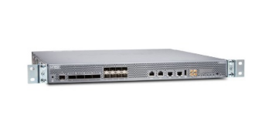

Juniper routers provide customers with a wide range of application scenarios, including branch, mid-size business, high-volume business, etc.

* [موجهات جونيبر MX204 / MX240 / MX480](https://ar.router-switch.com/juniper-mx204-mx240-mx480-routers-price.html)
* [موجهات جونيبر MX10003 / MX10008 / MX10016](https://ar.router-switch.com/juniper-mx10003-mx10008-mx10016-routers-price.html)
* [موجه جونيبر PTX1000 / 3000/5000/10000](https://ar.router-switch.com/juniper-ptx1000-3000-5000-10000-routers-price.html)
* [أجهزة التوجيه جونيبر الأخرى](https://ar.router-switch.com/juniper-other-routers-price.html)

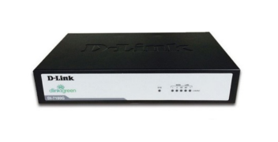

D-Link is a global leader in the design and development of networking and connectivity products for consumers, small businesses, medium and large enterprises, and service providers.

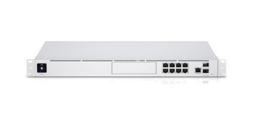

Ubiquiti / UBNT offers a wide range of wireless router models that allow users to solve any tasks - from deploying a Wi-Fi hotspot in a small room to a corporate wireless network.

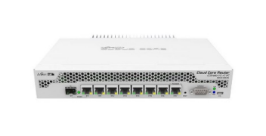

**Mikrotik:**

MikroTik routers are well suited for customers of any size who need an inexpensive router that provides all the features their network administrators need to secure and monitor their network.

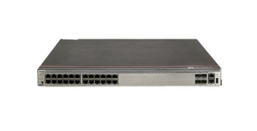**2-2. Switch:**

1. **Huawei Switches**

Huawei Switches are suitable for a variety of applications and network sizes, from cloud data centers to campus networks.

1. **DELL Switches**

Dell Transformers

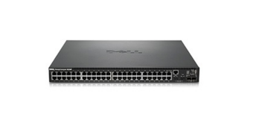Dell network switches offer different types, including web managed switches, managed pool, modular chassis switches, data center switches, M-Series cipher, etc.

* [Dell Networking X Series](https://ar.router-switch.com/dell-networking-x-series-switches-price.html)
* [Dell Networking N3000](https://ar.router-switch.com/dell-networking-n3000-switches-price.html)
* [Dell Networking S4048-ON](https://ar.router-switch.com/dell-networking-s4048-on-switches-price.html)
* [Dell Networking S4100-ON](https://ar.router-switch.com/dell-networking-s4100-on-switches-price.html)

1. **Cisco Switches**

Cisco switches provide campus LAN switches, industrial Ethernet switches, and other series for networks of all types and sizes, including branches, service providers, small and medium businesses, and so on.

* 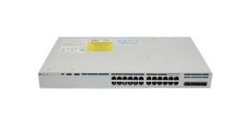[Cisco Switch Catalyst 9200](https://ar.router-switch.com/cisco-catalyst-9200-switches-price.html)
* [Cisco Switch Catalyst 9300](https://ar.router-switch.com/cisco-catalyst-9300-switches-price.html)
* [Cisco Switch Catalyst 9400](https://ar.router-switch.com/cisco-catalyst-9400-switches-price.html)
* [Cisco Switch Catalyst 9500](https://ar.router-switch.com/cisco-catalyst-9500-switches-price.html)

**Bottom of Form**

**2-3. Firewall:**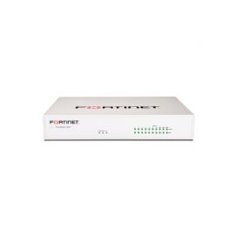

Price: 705.00 $

FortiGate 40F FG-40F ، 5 ports GE RJ45 ( 4 ×, ports ، 1 × ports WAN)

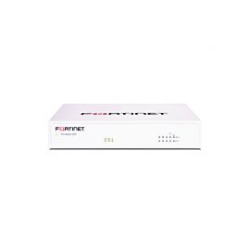Price: 526.00 $

- Amazon -

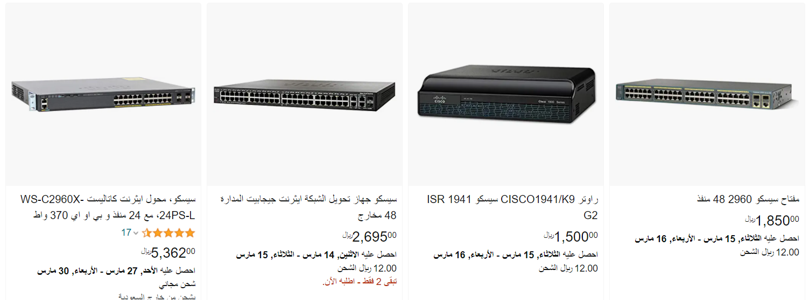

**2-4. All Enterprise Networking Products**

**2-4-1. Transformers**

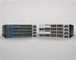Scales up to fit the needs of networks of all sizes with highly secure and reliable switching solutions from Cisco.

**2-4-2. Routers:**

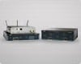A comprehensive suite of Cisco routers simplifies the process of building a secure, reliable, and scalable network at a lower cost.

**2-4-3. Wireless:**

 High-reliability Cisco Wireless Networking provides infrastructure with the ability to accelerate innovation for medium and enterprise organizations.

**2-4-4. Network Security:**

Reduce costs and reduce complexity with an architecture and systems approach to security.



**2-4-5. Cloud-Managed Meraki**

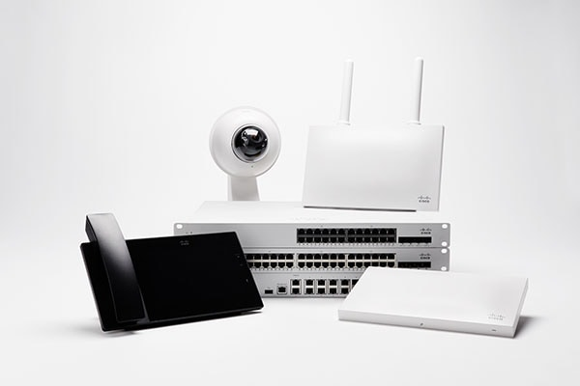

Cisco Meraki network devices are 100 percent cloud-managed for faster deployment, simpler management, and greater visibility.

**2-4-6. Network management:**

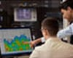Simplify network management, speed up service boot up, and improve user experience, all while lowering operational costs.

**2-4-6. WAN optimization**

Accelerate applications across a WAN, boost branch infrastructure, and enable online computing.

## **2-5. Cisco wireless**

Cisco Aironet Access Points Transition Guide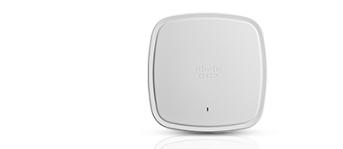

**Catalytic Wi-Fi 6 (802.11ax) Access Capture:**

Cisco Catalyst 9100 Access Points can handle next-generation network challenges. Going beyond the Wi-Fi 6 (802.11ax) standard, Catalyst 9100 Access Points are flexible and intelligent and provide integrated security for your mobile customers as well as your IoT devices.

* [access points Catalyst 9120](https://ar.router-switch.com/cisco-catalyst-9100-wi-fi-6-access-points-price.html)
* [access points Catalyst 9117](https://ar.router-switch.com/cisco-catalyst-9100-wi-fi-6-access-points-price.html)
* [access points Catalyst 9115](https://ar.router-switch.com/cisco-catalyst-9100-wi-fi-6-access-points-price.html)

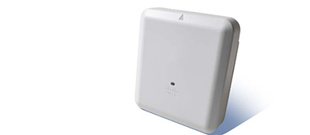

**802.11ac Wave 2 Aironet Access Points:**

Expanding the rich capabilities of the Aironet wallet, the Cisco Aironet 802.11ac Wave 2 AP delivers high performance, first-class security, and detailed analytics, including location.

* [access points Aironet 4800](https://ar.router-switch.com/cisco-aironet-4800-access-points-price.html)
* [Aironet 3800](https://ar.router-switch.com/cisco-3800-access-points-price.html)
* [Aironet 2800](https://ar.router-switch.com/cisco-2800-access-points-price.html)
  1. **Devices Used in Our Network (UOW):**
     1. **Router:**

Linksys WRT AC1900 Dual-Band+ Wi-Fi Wireless Router with Gigabit & USB 3.0 Ports and eSATA, Smart Wi-Fi Enabled to Control Your Network from Anywhere (WRT1900AC) Renewed

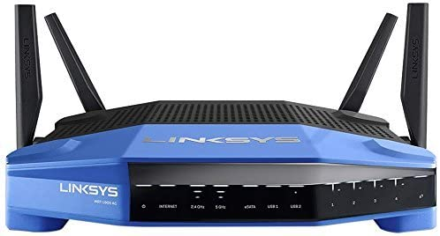

Price: $149.99

Wired or wireless, and it is better to buy a router that has two types of connection and has strong performance, and to reach a good choice you can learn about the specifications of a good router and how to choose the right type for you, especially if the number of employees is small in the company where we will rely mainly on it shortly, and For your convenience, you can rely on the Linksys WRT AC1900 Smart Wi-Fi Router, which is a good choice and also has strong performance.

* + 1. **Switch:**

The benefit of the patch panel lies in knowing the exact location of the two ends of the wire in order to remove it later or change it, for example, especially if the number of wires reaches 50, as for 20 or 10, you can rely on the switch without any problem and this is the difference between them, and here is an example In the shape of the switch, and in the picture, we find the D-link brand with 24 ports, 22 of them at a speed of 10/100 Mbps, and two ports on the right at a speed of 1 Gb/s. There are other excellent manufacturers of switches such as Cisco and 3com.

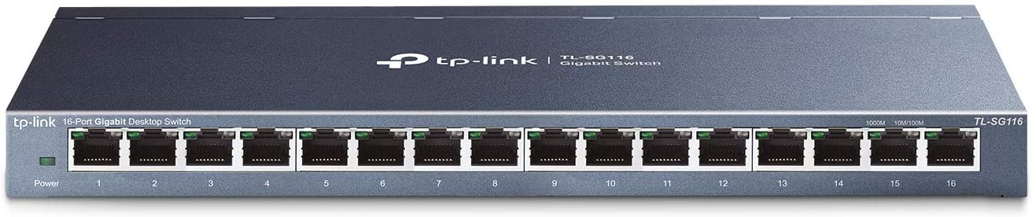

Price: $75.99

P-Link 16 Port Gigabit Ethernet Network Switch, Desktop/ Wall-Mount, Fanless, Sturdy Metal w/ Shielded Ports, Traffic Optimization, Unmanaged, Limited Lifetime Protection (TL-SG116) Black.

# Chapter Three

# Design

**3.1. introduction:**

The network design at Wasit University will be built first by default using the (Cisco Packet Tracer) program version 8, this program contains all the management that helps you to build an integrated network and experience the connection and link correctly in addition to the presence of all protocols to connect devices, routers and switches and we will use the following techniques in the design:

1. **Tools:**
2. **Network Devices**
3. **End Devices**
4. **Components**
5. **Connections**
6. **Miscellaneous**
7. **Multiusers Connection**

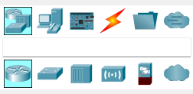

1. **Ip:**

An IP address is a unique address that identifies a device on the internet or a local network. IP stands for "Internet Protocol," which is the set of rules governing the format of data sent via the internet or local network

In essence, IP addresses are the identifier that allows information to be sent between devices on a network: they contain location information and make devices accessible for communication. The internet needs a way to differentiate between different computers, routers, and websites. IP addresses provide a way of doing so and form an essential part of how the internet works.

1. **Ping:**

A ping (Packet Internet or Inter-Network Groper) is a basic [Internet](https://www.techtarget.com/whatis/definition/Internet) program that allows a user to test and verify if a particular destination [IP address](https://www.techtarget.com/whatis/definition/IP-address) exists and can accept requests in computer network administration. The acronym was contrived to match the submariners' term for the sound of a returned sonar pulse.

1. **Vlan:**

A VLAN (virtual LAN) is a subnetwork which can group together collections of devices on separate physical local area networks (LANs). A LAN is a group of computers and devices that share a communications line or wireless link to a server within the same geographical area.

VLANs make it easy for network administrators to [partition](https://www.techtarget.com/searchstorage/definition/partition) a single switched network to match the functional and security requirements of their systems without having to run new cables or make major changes in their current network infrastructure. VLANs are often set up by larger businesses to re-partition devices for better traffic management.

VLANs are also important because they can help improve the overall performance of a network by grouping together devices that communicate most frequently. VLANs also provide security on larger networks by allowing a higher degree of control over which devices have access to each other. VLANs tend to be flexible because they are based on logical connections, rather than physical.

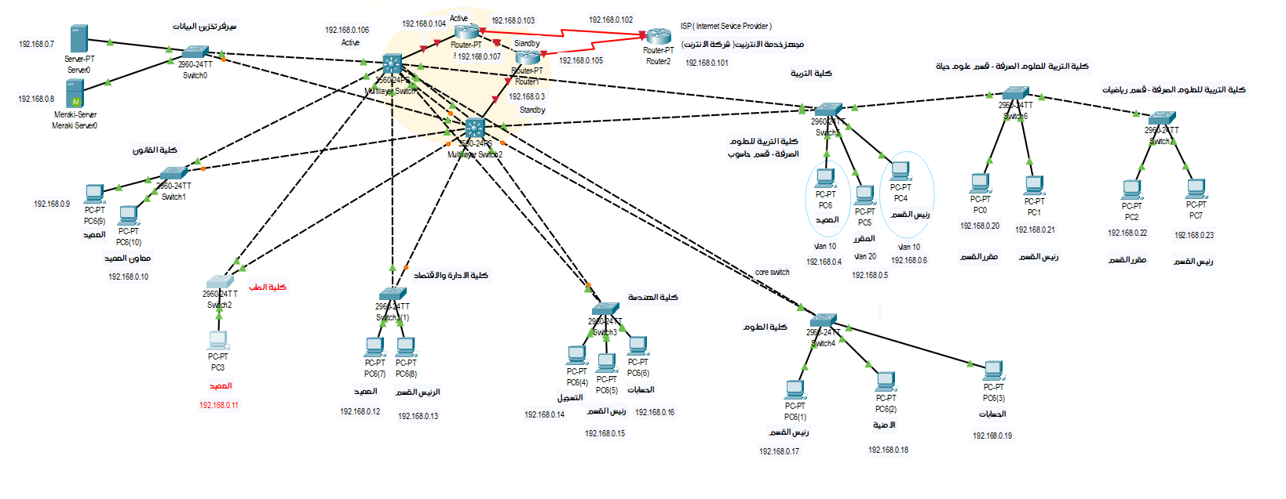

Figure 1 – Network of University of wasit

## 3-2. Design:

This network was designed by default using Cisco to simulate the practical reality and to know the number of devices and the method of connecting computers.

## **1 - Service Provider:**

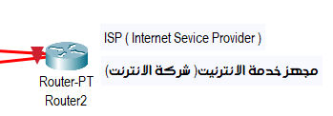

## **2 -Network Distributions :**

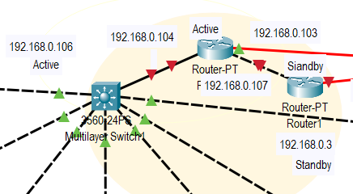

## **3- Faculty of Education:**

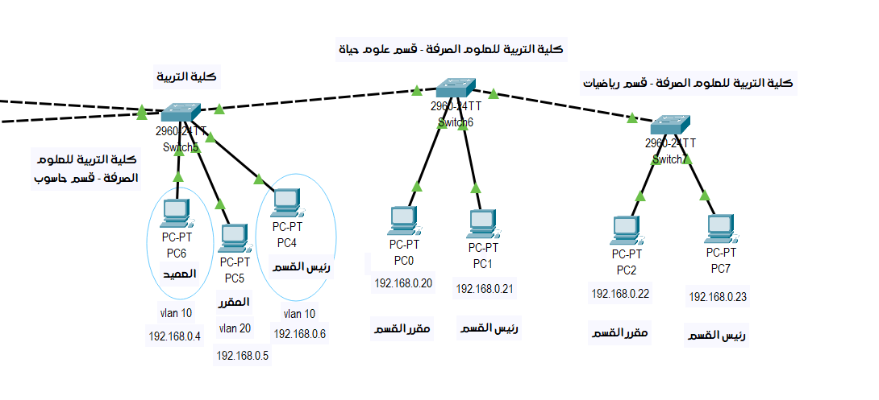

Figure 2 - Faculty of Education Network

1. **Computer:**

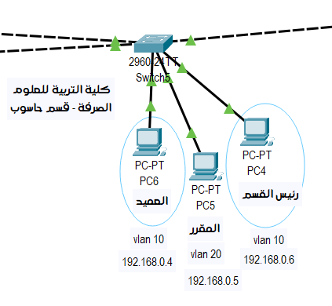

Figure 3 Department Computer

1. **Math:**

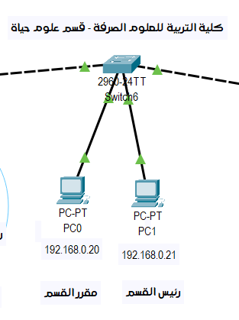

Figure 3. 1 - Department Math

1. **Biology:**

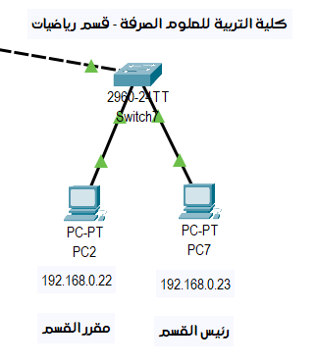

Figure 3. 2 - Department Biology

## **4- College of Science :**

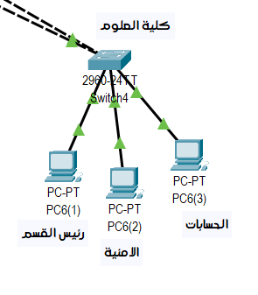

Figure 3. 3 - College of Science

## **5- College of Engineering :**

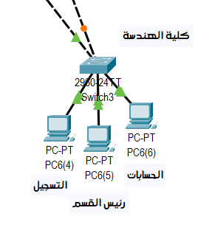

Figure 3. 4 - College of Engineering

## **6- Faculty of Administration and Economics:**

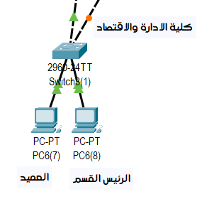

Figure 3. 5 - - Faculty of Administration and Economics

## **7- Faculty of medicine :**

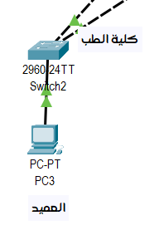

Figure 3. 6 - Faculty of medicine

## **8- College Of Law :**

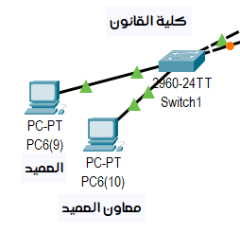

## **9- Data Storage Server :**

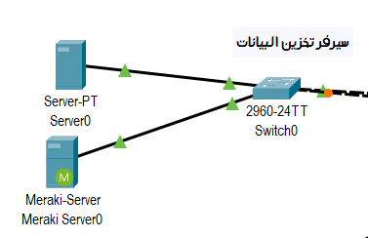

* 1. **Test Connection:**

**3.3.1. ping:**

We note from the previous diagrams that the network consists of several switches between the colleges connected together, and we test the connection between computers, so we try a test which is ping.

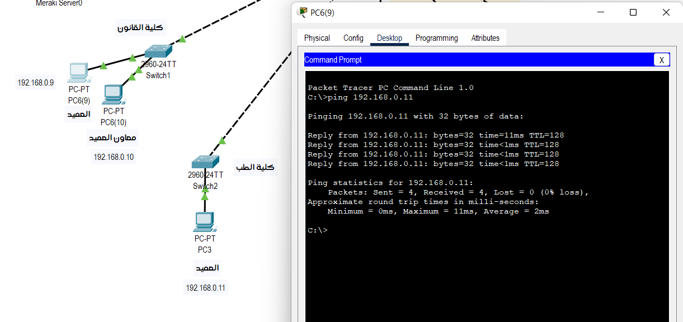

Figure 3. 7 - Ping Connection

# Here we conducted a communication test between the Dean of the Faculty of Medicine and the Dean of the Faculty of Law via the computer's IP.

**3.3.2. Simulation:**

Sending a message by simulating between devices in the network is done by sending a message from the source device to the source’s switch, then to the main switch, then it is transferred to the target switch, and then it is transmitted to the device to be sent to.

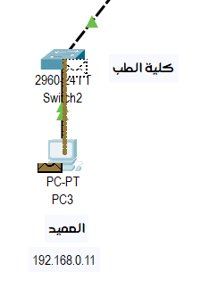 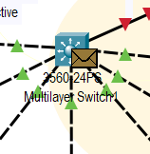 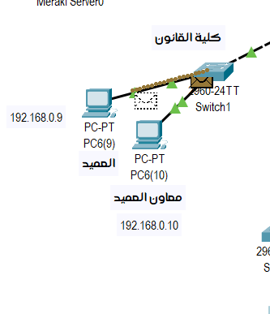

We do the icmp option because it is responsible for sending messages in the network.

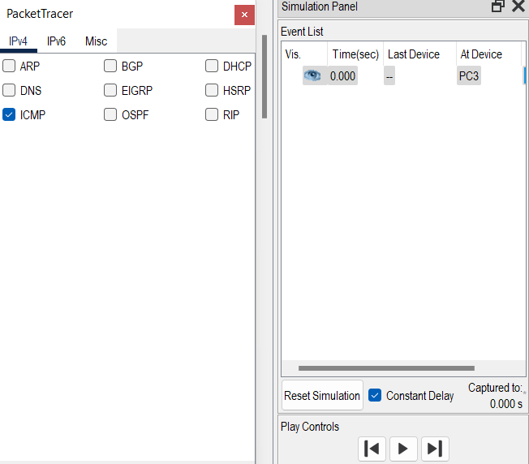

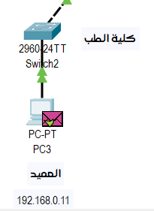

We note in this last picture that the message has been sent successfully.

# Chapter Four

implementation

Table 1 – Wires

|  |  |  |  |  |  |  |
| --- | --- | --- | --- | --- | --- | --- |
| # | Source | Destination | Wire Distance | Cable Type | Price /m | Total |
| 1 | Collage Of Education | College Of Fine Arts | 650 M | UTP | 0.19 $ | 123.5 $ |
| 2 | Collage Of Education | Faculty Of Administration And Economics | 500 M | STP | 0.28 $ | 140 $ |
| 3 | Collage Of Education | Medical College | 1.1 Km | Fiber | 0.20 $ | 220 $ |
| 4 | Collage Of Education | Agricultural Engineering | 1.3 Km | Fiber | 0.20 $ | 260 $ |
| 5 | Collage Of Education | Faculty Of Computer Science And Information Technology | 550 M | Fiber | 0.20 $ | 110 $ |
| 6 | Collage Of Education | Faculty Of Arts | 800 M | Fiber | 0.20 $ | 160 $ |
| 7 | Collage Of Education | Dormitories For Students Of Wasit University | 2.5 Km | Fiber | 0.20 $ | 500 $ |
| 8 | Collage Of Education | Wasit University Presidency | 600 M | Fiber | 0.20 $ | 120 $ |
| 9 | Collage Of Education | Wasit University Restaurant | 850 M | Fiber | 0.20 $ | 170$ |

Final Total: 1,803.5 $

Table 2 – College of Education

|  |  |  |  |  |
| --- | --- | --- | --- | --- |
| # | Department  Name | Department Distance | Wire Distance | Type |
| 1 | Computer | Head Of Department | 5 M | UTP |
| 2 | Computer | Math | 15 M | UTP |
| 3 | Computer | Biology | 30 M | UTP |
| 4 | Computer | Dean's Office | 45 M | UTP |
| 5 | Math | Head Of Department | 5 M | UTP |
| 6 | Math | Computer | 15 M | UTP |
| 7 | Math | Biology | 15 M | UTP |
| 8 | Math | Dean's Office | 20 M | UTP |
| 9 | Biology | Head Of Department | 5 M | UTP |
| 10 | Biology | Computer | 25 M | UTP |
| 11 | Biology | Math | 15 M | UTP |
| 12 | Biology | Dean's Office | 10 M | UTP |
| 12 | Dean's Office | Heads Of Departments | 40 – 50 M | UTP |
| 14 | Dean's Office | Math | 25 M | UTP |
| 15 | Dean's Office | Computer | 45 M | UTP |
| 16 | Dean's Office | Biology | 10 M | UTP |

Final Total: 119.7 $

Table 3 – Wireless vs Wire

|  |  |  |
| --- | --- | --- |
| # | Wire | Wireless |
| info | Wired network consists of wired connection between various components of the system. | Computer networks that are not linked or connected by any cable are known as wireless networks |
| Advantage | **Fast Transfer of Information**  **More Secure**  **Simple**  **Cables Offer Higher**  **Higher Reliability**  **Better Quality Of Service** | **Accessibility**  **Easy Installation**  **Wider Reach**  **Flexibility**  **Efficiency**  **Cost-Effective** |
| Disadvantages | **Does Not Provide Mobility During Usage**  **Very Difficult**  **It Requires Devices**  **There Are More Chances Of Damage To Wired Technology** | **Security:**  **Limited Bandwidth:**  **Speed:**  **Cost**  **Prone To Interference**  **Coverage** |

**Summary Of UTP And STP For Cables:**

• STP cables are shielded while UTP cables are unshielded

• STP cables are more immune to interference and noise than UTP cables

• STP cables are better at increasing bandwidth than UTP cables

• STP costs more per meter compared to UTP cables

• STP cables are heavier per meter compared to UTP cables

• UTP cabling is more common in SOHO networks, while STP is used in more advanced applications.

**Patch Panel:**

To simplify the term, it is a control panel similar to a switch in terms of form, but in terms of functionality, it works to organize and number the wires only to facilitate finding the end of the wire later on “a end in the wall, and a terminal without a jack that is connected to the patch panel, and up The number of ports in it is 48 ports per panel, and you will not find a unified form for it as there are different forms and they all perform the same function, but the idea is in the better organization.

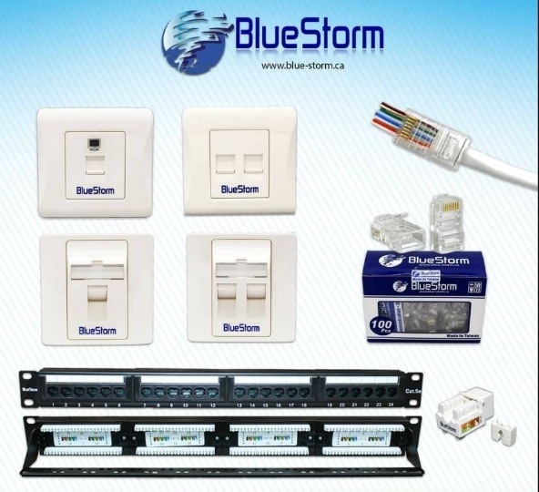1-Patch Panel Utp Cat5e 24ports---(24$)  
2-Patch Panel Utp Cat6 24ports ---(38$)  
3-RJ45 Cat5e Connector (100pcs) --(6$)  
4-RJ45 Cat6 Pass Through (100pcs) (20$)  
5-Keystone Utp Cat5e (1 Pc) ------(1.25$)  
6-Keystone Utp Cat6 (1 Pc) -------(1.75$)   
7-Face Plate Single Port-------------(1$)  
8-Face Plate Dual Port---------------(1.1$)  
9-Face Plate °45 Single Port---------(1.25$)  
10-Face Plate °45 Dual Port---------(1.5$)

Table 4 – Router Table

|  |  |  |
| --- | --- | --- |
| Location | Number of Routers | Price |
| College Of Education | 5 | $379.95 |
| Agricultural Engineering | **3** | **$227.97** |
| Faculty Of Computer Science and Information Technology | **3** | $227.97 |
| Faculty Of Arts | **2** | $151.98 |
| The Dormitories for Students Of Wasit University | **1** | $75.99 |
| Wasit University Presidency | **1** | $75.99 |
| Wasit University Restaurant | **1** | $75.99 |
| Wasit University Presidency | **4** | $303.96 |

Final Total: 1,519.84 $

**How To Link:**

1. First, the place designated for collecting wires must be determined, i.e. the main source or the room in which the “Rack” cabinet is located.

2. After specifying, extend the wires individually, of course, to the furthest point in the office, and then the next one until it approaches the cabinet, through one of the connection methods mentioned below.

3. After reaching the desired destination, let it be through the wall, a small part of the wire is taken out of the wall or the box in order to provide enough space to install it in the socket, then cut the other end in the cabin room next to the assembly plate, in preparation for stapling it to the board with the Punsh down tool, as shown in the video or in the Drywall section.

4. After stapling, the wires are attached to the panel by means of a plastic buckle in order to ensure that they are fixed in place in case the wires are tightened under any circumstances.

**Note**:

When stapling the wires, make sure to place them horizontally according to the colors displayed on the board. Standard B must be followed, as we will explain shortly. The two ends of the wire must be identical in terms of wire arrangement; Leaving the largest possible part of the wire coiled from the inside and spreading a small part to put it in the port only as shown in the following picture, in order to create a protection field around each pair of wires against external vibrations.

# Chapter Five

Conclusions & Recommendations

* 1. Conclusions
* الترجمة طويلة جدًا ولا يمكن حفظها.

The Wasta University network has been divided into several sections according to needs, such as colleges, departments, and others. The network can be connected with a server to store data, create programs and share them on a network. All colleges can communicate through messages between computers on the network. Routers and switches are connected and organized according to special requirements and needs. In every university, college, and department, a vlan was used to divide the network switches into virtual or fake networks to prevent hacking of the computer or information leakage from it by giving the computer vlan and giving the same number to each computer we want to connect to.

* 1. Recommendations

We recommend installing this project in University of Wasit to be easily managed and to monitor all operations, Exchange Information between Collages, expenses, student data and others.

# References

1. <https://ar.router-switch.com>
2. <https://www.amazon.sa/cisco/s?k=cisco>
3. S. Haller S. Karnouskos and C. Schroth "The

Internet of Things in an Enterprise Context "in Future Internet-FIS 2008 Lecture Notes in Computer Science Vol. 5468 2009 pp 14-28.

1. A. C. Sarma and J. Girão "Identities in the

Future Internet of Things” in Wireless Personal Communications 49.3 2009 pp. 353-363.

1. Roberto Minerva AbiyBiru "Towards a

Definition of the Internet of Things” IEEE IoT Initiative white paper.

1. <http://www.packettracernetwork.com/internetof-things/pt7-iot-devices-configuration.html>.
2. Current, John R., Charles S. ReVelle, and

Jared L. Cohon. "The hierarchical network design problem." European Journal of Operational Research 27.1 (1986): 57-66.

8- <https://uowasit.edu.iq/>